Salvatore Renda, AIA NCARB LEED AP
Dormitory Authority State of New York 515 Broadway Albany, New York 12047
t:(518) 257-3211 e: srenda@dasny.org web: www.dasny.org

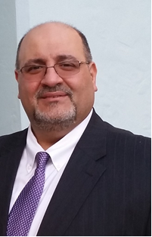
Salvatore Renda is an Architect and Chief Project Manager for Design & Construction with the Dormitory Authority of the State of New York. The Dormitory Authority provides financing and construction services to public and private universities, not-for-profit healthcare facilities, courts, libraries and other institutions that serve the public good

Mr. Renda and his staff manage and oversee projects including all phases of Planning, Design and Construction in the Upstate Eastern Region for DASNY

Mr. Renda is a member of the American Institute of Architects and has served as President and on the Board of Directors for the Eastern NY Chapter of AIA, the International Facility Management Association and the Building Commissioning Association. He currently holds certifications from the National Council of Architectural Registration Board and the American Concrete Institute. He is also a NYS Code Enforcement Official and is a USGBC LEED Accredited Professional.

.

Mr. Renda holds a Master of Architecture from the University of Buffalo, School of Architecture and Planning, a Bachelor of Science in Architecture from the New York Institute of Technology, Center for Architecture, and an Associate’s Degree in Applied Science in Civil Engineering from Hudson Valley Community College, School of Architectural, Civil and Construction Technology.

