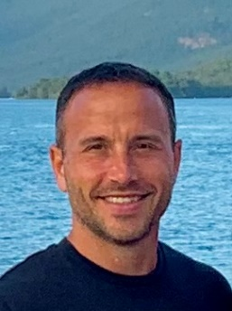
Marshall Vitale
New York State Office of Mental Health
Director of Administrative Services

Marshall oversees a large organization that’s responsible for physical plant operation and other non-clinical support services at OMH’s 26 State-operated campuses. This includes managerial oversight for roughly 800 design & construction projects valued at $2.2 billion, safety & security, Joint Commission accreditation, code compliance, fleet services, interior design, environmental remediation, real property management and nutrition services.
Marshall has nearly 25 years of experience with NYS government, previously holding high-level positions at the NYS Division of Budget and NYS Information Technology Services. Marshall received his undergraduate degree from Siena College and a master’s from SUNY Albany.

