Margaret M Carney FAIA

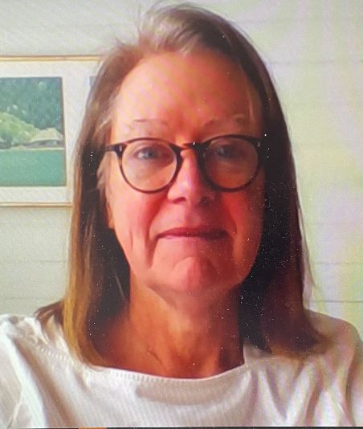

Margaret M. Carney FAIA, a graduate of Cornell University’s College of Architecture, Art and Planning, returned to Ithaca in 2018 as Cornell's University Architect to lead the planning and design of Cornell’s built environment. Prior to joining Cornell, Margaret served a total of 14 years as Associate VP, University Architect and Planner for three major American Universities: The Catholic University of America in Washington DC, Temple University in Philadelphia, and Case Western Reserve University in Cleveland, Ohio. She was the first University Architect and Planner for all three universities, where she led the development and implementation of numerous transformational campus master plans. On all three campuses she established the organization and processes of the Office of the University Architect, led the selection of architects and design teams for major capital projects, and guided the planning and design of significant academic, research, residential, and athletic facilities and landscape environments.

Earlier in her career, Margaret worked in various architecture firms including SOM in Chicago, The Architects Collaborative (TAC), Sasaki, and Ben Thompson Associates in Cambridge, Massachusetts. Key completed projects include Temple University's Charles Library (Snohetta), Morgan Hall Student Residence Tower (MGA Partners), and "Verdant Temple" Landscape Master Plan (Ground Reconsidered); "Uptown" Urban Development in Cleveland by Stanley Saitowitz as part of the Greater University Circle Community Development Project; and Cornell University's Atkinson Hall Research Facility which supports the University's ambitious "Radical Collaboration" initiative by co-locating the Cornell Atkinson Center for Sustainable Futures, and the departments of Cancer Biology, Immunology, Computational Biology and Masters of Public Health Program.

Throughout her career Margaret has served as a design critic for numerous urban design and architecture programs, and as an adjunct professor of Architecture and Urban Design at Kent State University, The Boston Architectural Center, and Temple University's School of Architecture. Margaret served as a member of the Cleveland Urban Design Center, the Design Review Board for the University Circle District in Cleveland, and as a Board Member for Philadelphia's AIA Center Board. In her role as University Architect Margaret has done a significant amount of public speaking and panel discussions at conferences and within communities about the importance of planning, landscape design and architecture in shaping communities. Her work and teaching, especially over the last 25 years, has focused on urban campuses and their impact on American Cities.

