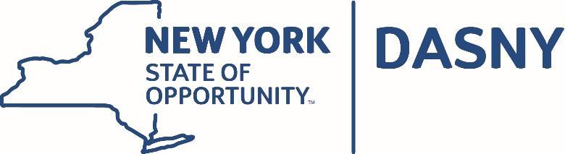

AGENDA

Dormitory Authority of the State of New York

Audit Committee Video Conference Meeting

Tuesday, June 19, 2018

Albany and New York City – 5:00 p.m.

GENERAL

- Minutes of the April 10, 2018 Meeting
- Dormitory Authority Basic Financial Statements for the Year Ended
March 31, 2018
- Annual Investment Report for the Year Ended March 31, 2018
- Public Authorities Accountability Act Annual Report

