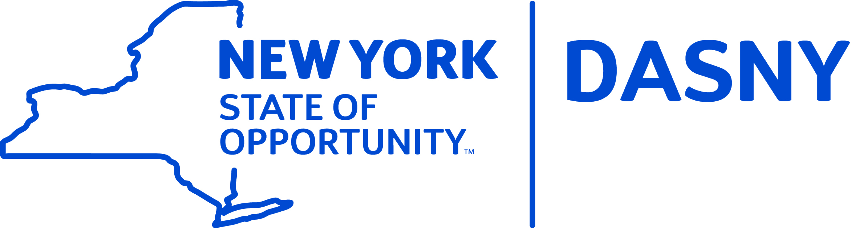

DORMITORY AUTHORITY OF THE STATE OF NEW YORK
NOTICE OF FINANCE COMMITTEE VIDEO CONFERENCE MEETING

A Finance Committee Video Conference Meeting of the Dormitory Authority of the State of New York will be held on Tuesday, July 17, 2018 at 4:00 p.m. at DASNY’s Albany Office, 515 Broadway, Albany, New York and New York City Office, One Penn Plaza 52nd Floor, New York, New York. Members of the public have the right to attend the Meeting at this location.

A video recording of the Meeting shall be accessible from DASNY’s website (www.dasny.org) not later than two business days after the close of the meeting.

Michael E. Cusack
Assistant Secretary

Dated: July 9, 2018

