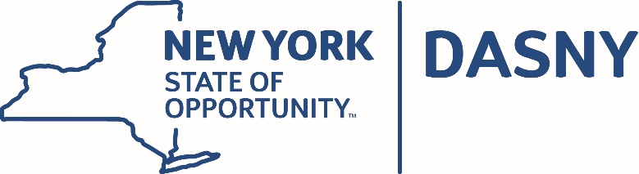

AGENDA

Dormitory Authority Audit Committee Video Conference Meeting

Tuesday, April 10, 2018

Albany and New York City Offices– 4:30 p.m.

GENERAL

- Minutes of the October 17, 2017 Meeting
- Audit Committee Charter - Annual Review

INTERNAL CONTROLS REPORT

- Internal Control Officer’s Report to the Audit Committee

INTERNAL AUDIT REPORT

- Director’s Report to the Audit Committee

